**Solidity Ethereum Lab Start**

Step -1

Open <https://remix.ethereum.org/>

Step-2

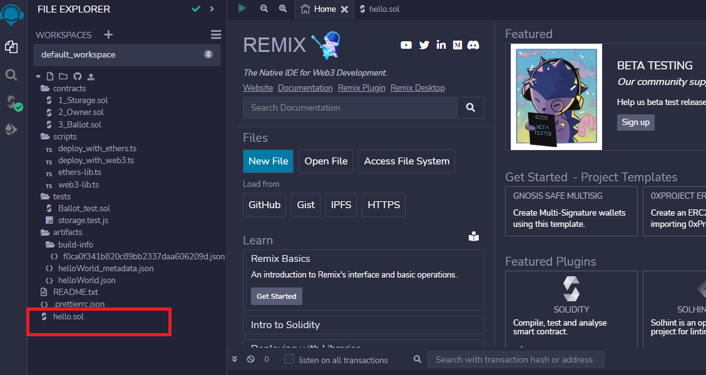

Create hello.sol Empty file

Step -3 Write the following sample Code in this file

pragma solidity ^0.4.22;

contract helloWorld {

 function renderHelloWorld () public pure returns (string) {

   return 'helloWorld';

 }

}

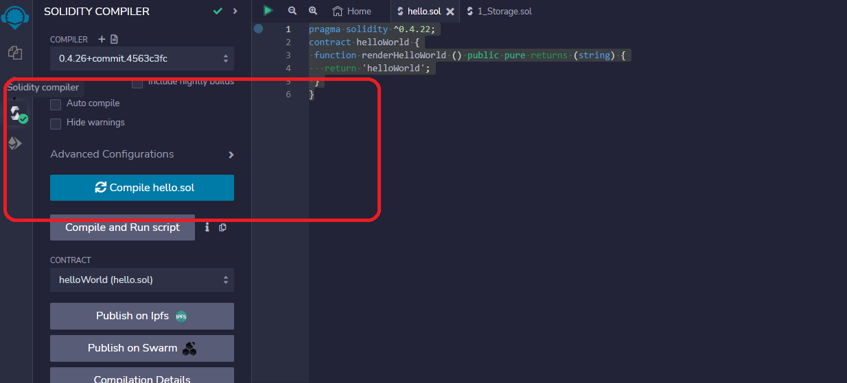

Compile the Following Code

Step-4 Select the public network for validation

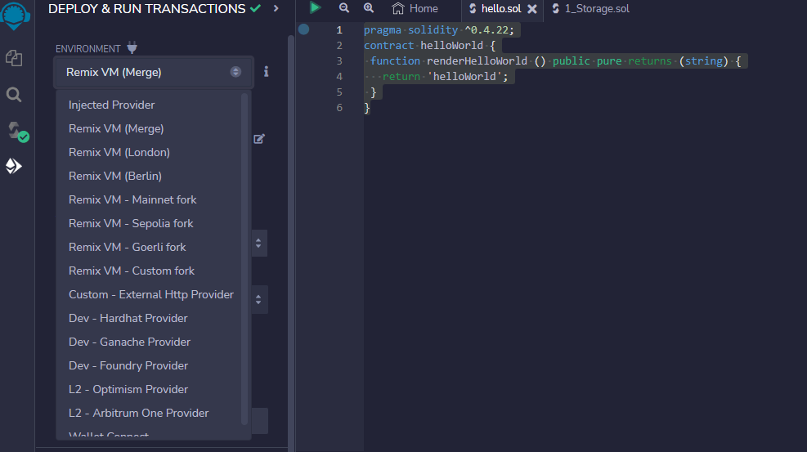

Step-5 Deploy the Contract Last step

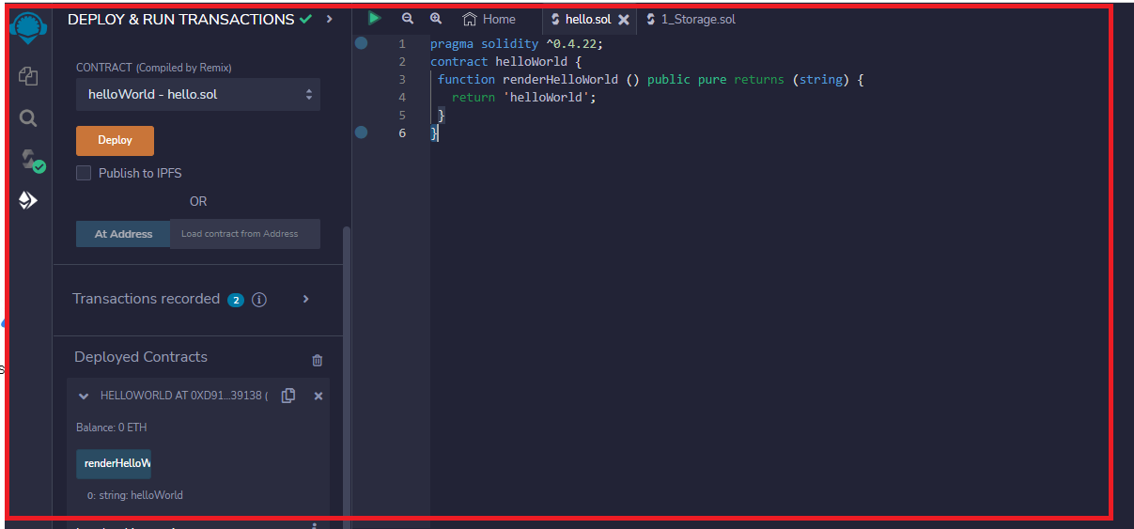

1. Task-1 : Authentication is the process of determining whether someone or something is, in fact, who or what it says it is. Authentication technology provides access control for systems by checking to see if a user's credentials match the credentials in a database of authorized users or in a data authentication server. In doing this, authentication assures secure systems, secure processes and enterprise information security. Write a code for Blockchain based authentication mechanism for for hello world message Transaction